
Tripoli Motor Testing Division
223 NC Highway 54 West
Chapel Hill, NC 27514
(919) 357 5681 (c)
April 16, 2024

Scott Kormeier
Loki Research, LLC
119 Mowrey Ln.
Theodosia, MO 65761

Dear Mr. Kormeier,

The Loki Research I-426LB reload kit was tested on March 30, 2024 and complies with NFPA 1125. The motor is certified for hobby rocketry use by the members of the Tripoli Rocketry Association and all approving organizations with reciprocal certifying agreements.

Motor Manufacturer Loki Research, LLC
Manufacturer’s Designation I-426 LB [made for the 38/480 hardware]
Propellant Loki Blue
TMT Nomenclature 505 I426

Diameter 1.499” 38.07 mm
Overall Length 12.078” 306.8 mm
Outside the MMT 0.61” 15.49 mm

Loaded Mass 1.2193 lb 553.05 g
Propellant Mass 0.516 lb* 234 g*
Burnout Mass 0.694 lb 314.77 g
* = data provided by manufacturer

Burn time 1.185 ± 0.014 sec

Total Impulse 113.54 ± 0.42 lbf.s 505.04 ± 1.87 N.s

Max Impulse 161.47 ± 9.79 lbf 718.26 ± 5.97 N
Average Impulse 95.70 ± 1.49 lbf 425.67 ± 6.60 N

Number of Motors Tested 3

Nominal Measured
Delay Time Data n.a. n.a.

Casing Temp. [NFPA 1125 7.4.1] Passed

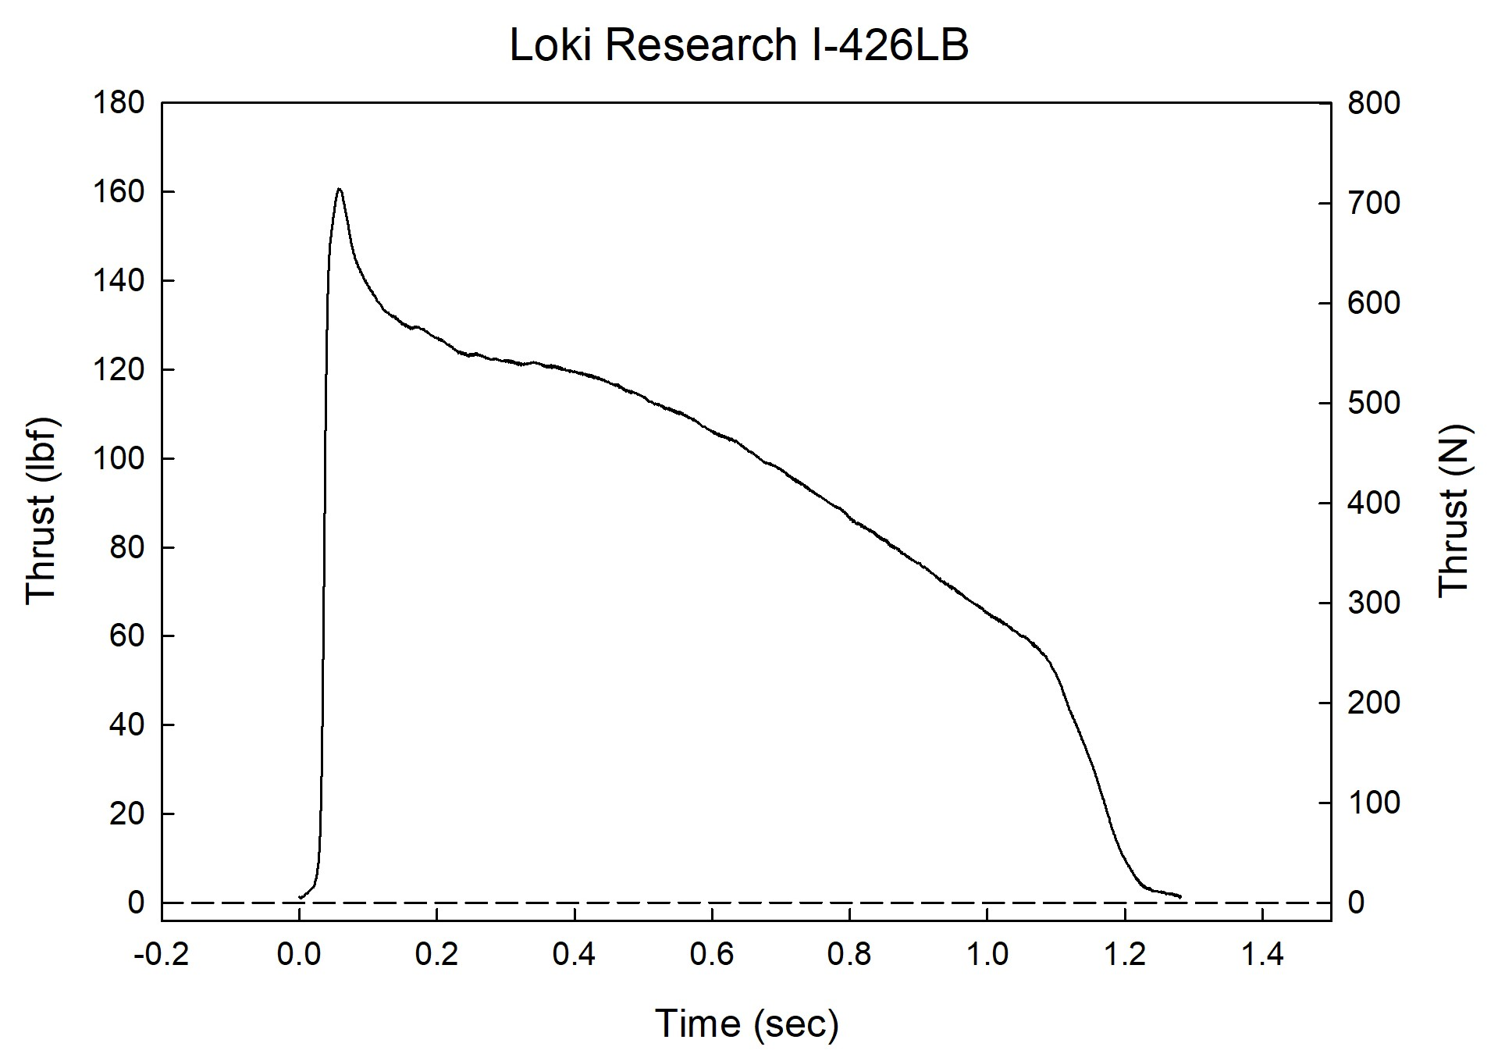

Sincerely,

Alan C. Whitmore
Chair, Tripoli Motor Testing

